Chapter 18
Capital Budgeting and Valuation with Leverage
18-1. Explain whether each of the following projects is likely to have risk similar to the average risk of the firm.
a. The Clorox Company considers launching a new version of Armor All designed to clean and protect notebook computers.
b. Google, Inc., plans to purchase real estate to expand its headquarters.
c. Target Corporation decides to expand the number of stores it has in the southeastern United States.
d. GE decides to open a new Universal Studios theme park in China.
a. While there may be some differences, the market risk of the cash flows from this new product is likely to be similar to Clorox’s other household products. Therefore, it is reasonable to assume it has the same risk as the average risk of the firm.
b. A real estate investment likely has very different market risk than Google’s other investments in Internet search technology and advertising. It would not be appropriate to assume this investment has risk equal to the average risk of the firm.
c. An expansion in the same line of business is likely to have risk equal to the average risk of the business.
d. The theme park will likely be sensitive to the growth of the Chinese economy. Its market risk may be very different from GE’s other divisions, and from the company as a whole. It would not be appropriate to assume this investment has risk equal to the average risk of the firm.
18-2. Suppose Caterpillar, Inc., has 665 million shares outstanding with a share price of $74.77, and $25 billion in debt. If in three years, Caterpillar has 700 million shares outstanding trading for $83 per share, how much debt will Caterpillar have if it maintains a constant debt-equity ratio?
E = 665 million × $74.77 = $49.7 billion, D = $25 billion, D/E = 25/49.722 = 0.503.
E = 700 million × $83.00 = $58.1 billion. Constant D/E implies D = 58.1 × 0.503 = $29.2 billion.
18-3. In 2012, Intel Corporation had a market capitalization of $121 billion, debt of $7.2 billion, cash of $14.7 billion, and EBIT of nearly $18 billion. If Intel were to increase its debt by $1 billion and use the cash for a share repurchase, which market imperfections would be most relevant for understanding the consequence for Intel’s value? Why?
Intel’s debt is a tiny fraction of its total value. Indeed, Intel has more cash than debt, so its net debt is negative. Intel is also very profitable; at an interest rate of 6%, interest on Intel’s debt is only $432 million per year, which is less than 2.5% of its EBIT. Thus, the risk that Intel will default on its debt is extremely small. This risk will remain extremely small even if Intel borrows an additional $1 billion. Thus, adding debt will not really change the likelihood of financial distress for Intel (which is nearly zero), and thus will also not lead to agency conflicts. As a result, the most important financial friction for such a debt increase is the tax savings Intel would receive from the interest tax shield. A secondary issue may be the signaling impact of the transaction—borrowing to do a share repurchase is usually interpreted as a positive signal that management may view the shares to be underpriced.
18-4. Suppose Goodyear Tire and Rubber Company is considering divesting one of its manufacturing plants. The plant is expected to generate free cash flows of $1.5 million per year, growing at a rate of 2.5% per year. Goodyear has an equity cost of capital of 8.5%, a debt cost of capital of 7%, a marginal corporate tax rate of 35%, and a debt-equity ratio of 2.6. If the plant has average risk and Goodyear plans to maintain a constant debt-equity ratio, what after-tax amount must it receive for the plant for the divestiture to be profitable?
We can compute the levered value of the plant using the WACC method. Goodyear’s WACC is
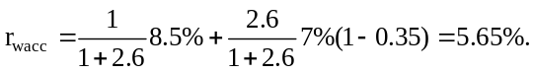
Therefore, 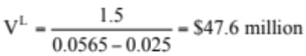
A divestiture would be profitable if Goodyear received more than $47.6 million after tax.
18-5. Suppose Alcatel-Lucent has an equity cost of capital of 10%, market capitalization of $10.8 billion, and an enterprise value of $14.4 billion. Suppose Alcatel-Lucent’s debt cost of capital is 6.1% and its marginal tax rate is 35%.
a. What is Alcatel-Lucent’s WACC?
b. If Alcatel-Lucent maintains a constant debt-equity ratio, what is the value of a project with average risk and the following expected free cash flows?
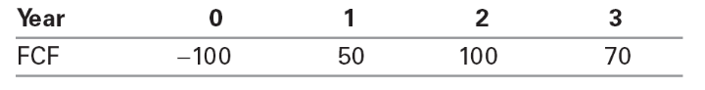
c. If Alcatel-Lucent maintains its debt-equity ratio, what is the debt capacity of the project in part b?
a. 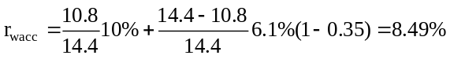
b. Using the WACC method, the levered value of the project at date 0 is
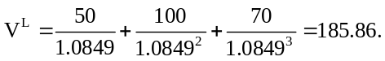
Given a cost of 100 to initiate, the project’s NPV is 185.86 – 100 = 85.86.
c. Alcatel-Lucent’s debt-to-value ratio is d = (14.4 – 10.8) / 14.4 = 0.25. The project’s debt capacity is equal to d times the levered value of its remaining cash flows at each date.
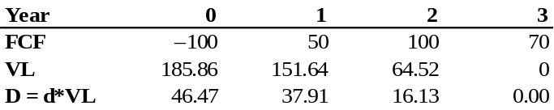
18-6. Acort Industries has 10 million shares outstanding and a current share price of $40 per share. It also has long-term debt outstanding. This debt is risk free, is four years away from maturity, has annual coupons with a coupon rate of 10%, and has a $100 million face value. The first of the remaining coupon payments will be due in exactly one year. The riskless interest rates for all maturities are constant at 6%. Acort has EBIT of $106 million, which is expected to remain constant each year. New capital expenditures are expected to equal depreciation and equal $13 million per year, while no changes to net working capital are expected in the future. The corporate tax rate is 40%, and Acort is expected to keep its debt-equity ratio constant in the future (by either issuing additional new debt or buying back some debt as time goes on).
a. Based on this information, estimate Acort’s WACC.
b. What is Acort’s equity cost of capital?
a. We don’t know Acort’s equity cost of capital, so we cannot calculate WACC directly. However, we can compute it indirectly by estimating the discount rate that is consistent with Acort’s market value. First, E = 10 × 40 = $400 million. The market value of Acort’s debt is
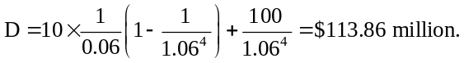
Therefore, Acort’s enterprise value is E + D = 400 + 113.86 = 513.86.
Acort’s FCF = EBIT × (1 – 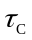) + Dep – Capex – Inc in NWC
FCF = 106 × (1 – 0.40) = 63.6
Because Acort is not expected to grow,
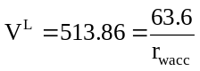 and so 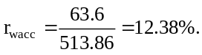
b. Using 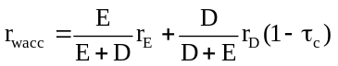,
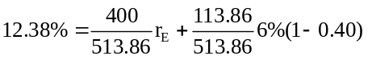
solving for r_{E}:
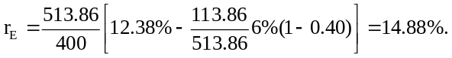
18-7. Suppose Goodyear Tire and Rubber Company has an equity cost of capital of 8.5%, a debt cost of capital of 7%, a marginal corporate tax rate of 35%, and a debt-equity ratio of 2.6. Suppose Goodyear maintains a constant debt-equity ratio.
a. What is Goodyear’s WACC?
b. What is Goodyear’s unlevered cost of capital?
c. Explain, intuitively, why Goodyear’s unlevered cost of capital is less than its equity cost of capital and higher than its WACC.
a. 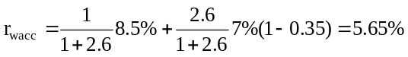
b. Because Goodyear maintains a target leverage ratio, we can use Eq. 18.6:
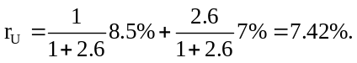
c. Goodyear’s equity cost of capital exceeds its unlevered cost of capital because leverage makes equity riskier than the overall firm. Goodyear’s WACC is less than its unlevered cost of capital because the WACC includes the benefit of the interest tax shield.
18-8. You are a consultant who was hired to evaluate a new product line for Markum Enterprises. The upfront investment required to launch the product line is $10 million. The product will generate free cash flow of $750,000 the first year, and this free cash flow is expected to grow at a rate of 4% per year. Markum has an equity cost of capital of 11.3%, a debt cost of capital of 5%, and a tax rate of 35%. Markum maintains a debt-equity ratio of 0.40.
a. What is the NPV of the new product line (including any tax shields from leverage)?
b. How much debt will Markum initially take on as a result of launching this product line?
c. How much of the product line’s value is attributable to the present value of interest tax shields?
a. WACC = (1 / 1.4)(11.3%) + (.4 / 1.4)(5%)(1 – .35) = 9%
V^{L} = 0.75 / (9% − 4%) = $15 million
NPV = –10 + 15 = $5 million
b. Debt-to-Value ratio is (0.4) / (1.4) = 28.57%.
Therefore Debt is 28.57% × $15 million = $4.29 million.
c. Discounting at r_{u} gives unlevered value. r_{u} = (1 / 1.4)11.3% + (.4 / 1.4)5% = 9.5%
V^{u} = 0.75 / (9.5% − 4%) = $13.64 million
Tax shield value is therefore 15 – 13.64 = 1.36 million.
Alternatively, initial debt is $4.29 million, for a tax shield in the first year of 4.29 × 5% × 0.35 = 0.075 million. Then PV(ITS) = 0.075 / (9.5% – 4%) = 1.36 million.
Alternatively, initial debt is $4.29 million, for a tax shield in the first year of 4.29 × 5% × 0.35 = 0.075 million. Then PV(ITS) = 0.075 / (9.5% – 4%) = 1.36 million.
18-9. Consider Alcatel-Lucent’s project in Problem 5.
a. What is Alcatel-Lucent’s unlevered cost of capital?
b. What is the unlevered value of the project?
c. What are the interest tax shields from the project? What is their present value?
d. Show that the APV of Alcatel-Lucent’s project matches the value computed using the WACC method.
a. 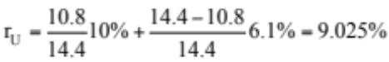
b. 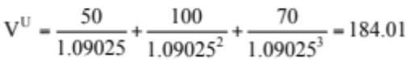
c. Using the results from problem 5(c):
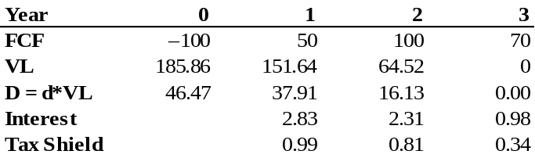
The present value of the interest tax shield is
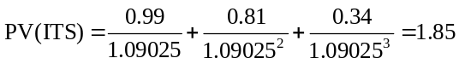
d. V^{L} = APV = 184.01 + 1.85 = 185.86
This matches the answer in problem 5.
18-10. Consider Alcatel-Lucent’s project in Problem 5.
a. What is the free cash flow to equity for this project?
b. What is its NPV computed using the FTE method? How does it compare with the NPV based on the WACC method?
a. Using the debt capacity calculated in problem 5, we can compute FCFE by adjusting FCF for after-tax interest expense (D × r_{D} × (1 – tc)) and net increases in debt (D_{t} – D_{t – 1}).
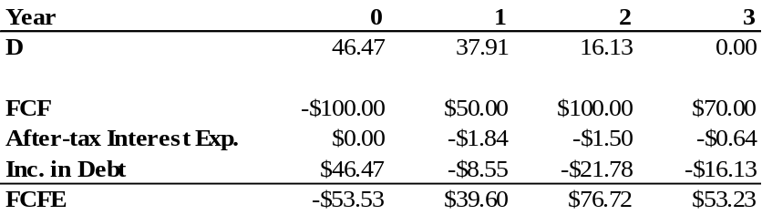
b. 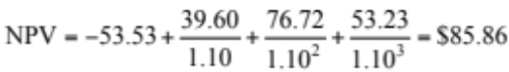
18-11. In year 1, AMC will earn $2000 before interest and taxes. The market expects these earnings to grow at a rate of 3% per year. The firm will make no net investments (i.e., capital expenditures will equal depreciation) or changes to net working capital. Assume that the corporate tax rate equals 40%. Right now, the firm has $5000 in risk-free debt. It plans to keep a constant ratio of debt to equity every year, so that on average the debt will also grow by 3% per year. Suppose the risk-free rate equals 5%, and the expected return on the market equals 11%. The asset beta for this industry is 1.11.
a. If AMC were an all-equity (unlevered) firm, what would its market value be?
b. Assuming the debt is fairly priced, what is the amount of interest AMC will pay next year? If AMC’s debt is expected to grow by 3% per year, at what rate are its interest payments expected to grow?
c. Even though AMC’s debt is riskless (the firm will not default), the future growth of AMC’s debt is uncertain, so the exact amount of the future interest payments is risky. Assuming the future interest payments have the same beta as AMC’s assets, what is the present value of AMC’s interest tax shield?
d. Using the APV method, what is AMC’s total market value, V L? What is the market value of AMC’s equity?
e. What is AMC’s WACC? (Hint: Work backward from the FCF and V L.)
f. Using the WACC method, what is the expected return for AMC equity?
g. Show that the following holds for AMC: 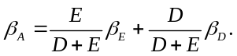
h. Assuming that the proceeds from any increases in debt are paid out to equity holders, what cash flows do the equity holders expect to receive in one year? At what rate are those cash flows expected to grow? Use that information plus your answer to part (f ) to derive the market value of equity using the FTE method. How does that compare to your answer in part (d)?
a. AMC has unlevered FCF of 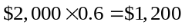.
From the CAPM, AMC’s unlevered cost of capital is 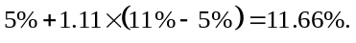
Discounting the FCF as a growing perpetuity tells us that the value of the firm, assuming growth of 3%, is:
V(All Equity)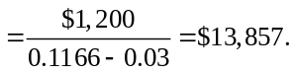
b. Since the debt is risk-free, the interest rate paid on it must equal the risk-free rate of 5% (or else there would be an arbitrage opportunity). The firm has $5,000 of debt next year. The interest payment will be 5% of that, or $250. If the debt grows by 3% per year, so will the interest payments.
c. The expected value of next year’s tax shield will be $250 × 40% = $100, and it will grow (with the growth of the debt) at a rate of 3%. But the exact amount of the tax shield is uncertain, since AMC may add new debt or repay some debt during the year, depending on their cash flows. This makes the actual amount of the tax shield risky (even though the debt itself is not). Since the beta of the tax shield due to debt is 1.11, the appropriate discount rate is 5% + 1.11 (11% – 5%) = 11.67%. We can now use the growing perpetuity formula and conclude that
PV(Interest Tax Shields) = 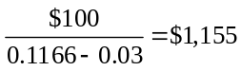.
d. The APV tells us that the value of a firm with debt equals the sum of the value of an all-equity firm and the tax shield. From previous work (parts (a) and (c)), we get:
V(AMC) = $13,857 + $1,155 = $15,012.
The market value of the equity is therefore V – D = $15,012 – $5000 = $10,012.
e. Next year’s FCF is . It is expected to grow at 3%, so the WACC must satisfy:
V(AMC) 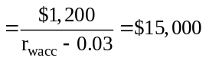.
Solving for the WACC, we get WACC = 11 %.
f. By definition, 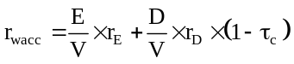.
The return on the debt is 5%; the value of the debt is $5,000, the value of the firm is $15,000 and therefore the value of the equity is $15,000 – $5,000 = $10,000. Plugging into the above expression, we get:
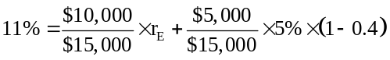  = 15%.
g. From the CAPM, 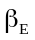 must satisfy 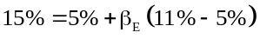, so we conclude 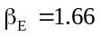.
The relationship holds since ($10,000/$15,000) × 1.66 = 1.11, and the beta of the debt equals 0.
h. The debt is expected to increase to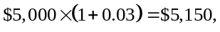 so the equity holders will get $150 due to the increase in debt. These proceeds will increase by 3% annually. (The second-year debt will be 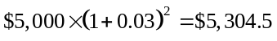, with an increase in debt of $154.5, 3% higher than the $150 proceeds of year 1.) The expected FCF to equity at the end of the first year is therefore EBIT – Interest – Taxes + Debt proceeds, or FCFE = (2000 – 250) (1 – .40) + 150 = $1200.
This cash flow is expected to grow at 3% per year. Thus, another way to compute the value of equity is to discount these cash flows directly at the MCR for the equity of 15% (from (f)):
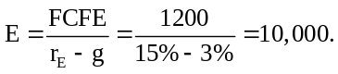
This is the same value we computed in (d), using the APV.
18-12. Prokter and Gramble (PKGR) has historically maintained a debt-equity ratio of approximately 0.20. Its current stock price is $50 per share, with 2.5 billion shares outstanding. The firm enjoys very stable demand for its products, and consequently it has a low equity beta of 0.50 and can borrow at 4.20%, just 20 basis points over the risk-free rate of 4%. The expected return of the market is 10%, and PKGR’s tax rate is 35%.
a. This year, PKGR is expected to have free cash flows of $6.0 billion. What constant expected growth rate of free cash flow is consistent with its current stock price?
b. PKGR believes it can increase debt without any serious risk of distress or other costs. With a higher debt-equity ratio of 0.50, it believes its borrowing costs will rise only slightly to 4.50%. If PKGR announces that it will raise its debt-equity ratio to 0.5 through a leveraged recap, determine the increase in the stock price that would result from the anticipated tax savings.
a. E = $50 × 2.5 B = $125 B
D = 0.20 × 125 B = $25 B
V^{L} = E +D = $150 B
From CAPM: Equity Cost of Capital = 4% + 0.5(10% – 4%) = 7%
WACC = (125 / 150) 7% + (25 / 150) 4.2% (1 – 35%) = 6.29%
V^{L} = FCF/(r_{wacc} – g) ⇒ g = r_{wacc} – FCF/V = 6.29% – 6/150 = 2.29%
b. Initial Unlevered cost of capital (Eq. 18.6) = (125 / 150) 7% + (25 / 150) 4.2% = 6.53%
New Equity cost of capital (Eq. 18.10) = 6.53% + (0.5)(6.53% – 4.5%) = 7.55%
New WACC = (1 / 1.5) 7.55% + (0.5 / 1.5) 4.5% (1 – 35%) = 6.01%
V^{L} = FCF / (r_{wacc} – g) = 6.0 / (6.01% – 2.29%) = 161.29
This is a gain of 161.29 – 150 = $11.29 B or 11.29/2.5 = $4.52 per share.
Thus, share price rises to $54.52/share.
18-13. Amarindo, Inc. (AMR), is a newly public firm with 10 million shares outstanding. You are doing a valuation analysis of AMR. You estimate its free cash flow in the coming year to be $15 million, and you expect the firm’s free cash flows to grow by 4% per year in subsequent years. Because the firm has only been listed on the stock exchange for a short time, you do not have an accurate assessment of AMR’s equity beta. However, you do have beta data for UAL, another firm in the same industry:
AMR has a much lower debt-equity ratio of 0.30, which is expected to remain stable, and its debt is risk free. AMR’s corporate tax rate is 40%, the risk-free rate is 5%, and the expected return on the market portfolio is 11%.
a. Estimate AMR’s equity cost of capital.
b. Estimate AMR’s share price.
a. From Eq. 14.9, UAL Asset beta = (1/2) 1.5 + (1/2) 0.3 = 0.90
We can use this for AMR’s asset beta.
To derive the equity beta, since AMR’s debt is risk free we have (Eq. 14.10):
Equity Beta = Asset Beta × (1 + D/E) = 0.9 × 1.30 = 1.17.
From the SML
r_{e} = 5% + 1.17(11% – 5%) = 12.02%.
Alternatively, given an asset or unlevered beta of 0.90 for AMR, we have (from SML):
r_{u} = 5% + 0.90(11% – 5%) = 10.4%.
Then we can solve for r_{e} using Eq. 18.10:
r_{e} = 10.4% + 0.30 (10.4% – 5%) = 12.02%.
b. Since D/E ratio is stable, we can value AMR using the WACC approach.
WACC = (1/1.3) 12.02% + (.3/1.3) 5% (1 – 40%) = 9.94%
Levered value of AMR (as a constant growth perpetuity):
D + E = V^{L} = FCF/(r_{wacc} – g) = 15 / (9.94% – 4%) = $252.52 million
E = (E / (D + E)) × V^{L} = 252.52 / 1.3 = $194.25 million
Share price = 194.25 / 10 = $19.43

18-14. Remex (RMX) currently has no debt in its capital structure. The beta of its equity is 1.50. For each year into the indefinite future, Remex’s free cash flow is expected to equal $25 million. Remex is considering changing its capital structure by issuing debt and using the proceeds to buy back stock. It will do so in such a way that it will have a 30% debt-equity ratio after the change, and it will maintain this debt-equity ratio forever. Assume that Remex’s debt cost of capital will be 6.5%. Remex faces a corporate tax rate of 35%. Except for the corporate tax rate of 35%, there are no market imperfections. Assume that the CAPM holds, the risk-free rate of interest is 5%, and the expected return on the market is 11%.
a. Using the information provided, complete the following table:
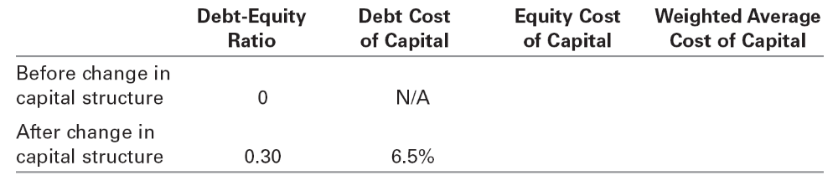
b. Using the information provided and your calculations in part a, determine the value of the tax shield acquired by Remex if it changes its capital structure in the way it is considering.
a. Before Change: From the SML,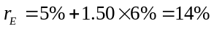
Since the firm has no leverage, 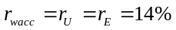.
After the change, from Eq. 18.10:
Since the firm has D/E of 0.30, the WACC formula is
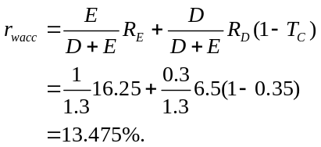
We can also use Eq. 18.11: r_{wacc} = 14% − (0.3 / 1.3)(0.35)(6.5%) = 13.475%.
b. We can compare Remex’s value with and without leverage. Without leverage (and no expected growth),
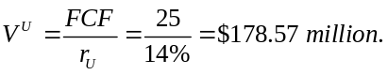
With leverage (and no expected growth):
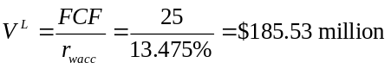
Therefore, PV(ITS) = V^{L} – V^{U} = 185.53 – 178.57 = $6.96 million.
18-15. You are evaluating a project that requires an investment of $90 today and provides a single cash flow of $115 for sure one year from now. You decide to use 100% debt financing, that is, you will borrow $90. The risk-free rate is 5% and the tax rate is 40%. Assume that the investment is fully depreciated at the end of the year, so without leverage you would owe taxes on the difference between the project cash flow and the investment, that is, $25.
a. Calculate the NPV of this investment opportunity using the APV method.
b. Using your answer to part a, calculate the WACC of the project.
c. Verify that you get the same answer using the WACC method to calculate NPV.
d. Finally, show that flow-to-equity also correctly gives the NPV of this investment opportunity.
a. FCF at year end (after tax) = 115 – 0.40 × 25 = 105
Vu = 105/1.05 = 100
PV(its) = 40% × 5% × 90/1.05 = 1.71
VL = 100 + 1.71 = 101.71
NPV = 101.71 – 90 = 11.71
b. r_{u} = r_{d} = 5%, d = 90/101.71
τ_{c} = 40%,
WACC = 5% – (90/101.71)(40%)(5%) = 3.23%
NOTE: if r_{u} = r_{d}, must use techniques in section 18.8 to calculate WACC.
c. VL = 105/1.0323 = 101.71
NPV = 101.71 – 90 = 11.71
d. FCFE₀ = 0
FCFE₁ = 105 – 5%(90)(1 – 40%) – 90 = 12.3
R_e = 5% (since no risk)
Value to equity = 12.3/1.05 = 11.71
18-16. Tybo Corporation adjusts its debt so that its interest expenses are 20% of its free cash flow. Tybo is considering an expansion that will generate free cash flows of $2.5 million this year and is expected to grow at a rate of 4% per year from then on. Suppose Tybo’s marginal corporate tax rate is 40%.
a. If the unlevered cost of capital for this expansion is 10%, what is its unlevered value?
b. What is the levered value of the expansion?
c. If Tybo pays 5% interest on its debt, what amount of debt will it take on initially for the expansion?
d. What is the debt-to-value ratio for this expansion? What is its WACC?
e. What is the levered value of the expansion using the WACC method?
a. Unlevered value V^{U} = FCF / (r_{U} – g) = 2.5 / (10% – 4%) = $41.67 million
b. From Eq. 18.14, V^{L} = (1 + τ_{c} k) V^{U} = (1 + 0.40 × 0.20) 41.67 = $45 million
c. Interest = 20%(FCF) = 20%(2.5) = $0.5 million = r_{D} D = 0.05 D
Therefore, D = 0.5 / 0.05 = $10 million
d. Debt-to-value d = D / V^{L} = 10 / 45 = 0.2222.
From Eq. 18.11, r_{wacc} = 10% – (0.2222)(0.40)5% = 9.556%
e. Using the WACC method, V^{L} = 2.5 / (9.556% – 4%) = $45 million
18-17. You are on your way to an important budget meeting. In the elevator, you review the project valuation analysis you had your summer associate prepare for one of the projects to be discussed:
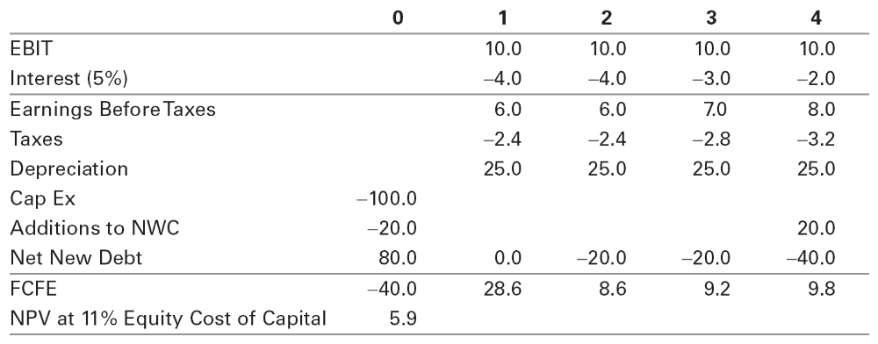
Looking over the spreadsheet, you realize that while all of the cash flow estimates are correct, your associate used the flow-to-equity valuation method and discounted the cash flows using the company’s equity cost of capital of 11%. However, the project’s incremental leverage is very different from the company’s historical debt-equity ratio of 0.20: For this project, the company will instead borrow $80 million upfront and repay $20 million in year 2, $20 million in year 3, and $40 million in year 4. Thus, the project’s equity cost of capital is likely to be higher than the firm’s, not constant over time—invalidating your associate’s calculation.
Clearly, the FTE approach is not the best way to analyze this project. Fortunately, you have your calculator with you, and with any luck you can use a better method before the meeting starts.
a. What is the present value of the interest tax shield associated with this project?
b. What are the free cash flows of the project?
c. What is the best estimate of the project’s value from the information given?
a. First,
Interest Payment = Interest Rate (5%) × Prior period debt
From the tax calculation in the spreadsheet, we can see that the tax rate is 2.4/6 = 40%. Therefore,
Interest Tax shield = Interest Payment × Tax Rate (40%)
Because the tax shields are predetermined, we can discount them using the 5% debt cost of capital.
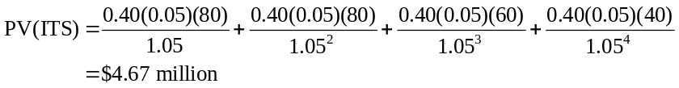
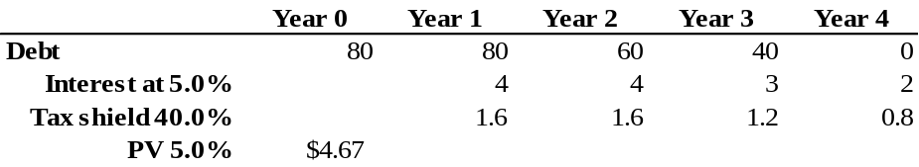
b. We can use Eq. 7.5:
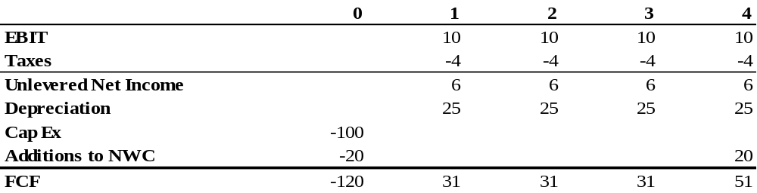
FCF = EBIT × (1 – T_{c}) + Depreciation – CapEx – ΔNWC
Alternatively, we can use Eq. 18.9:
FCF = FCFE + Int × (1 – T_{C}) – Net New Debt
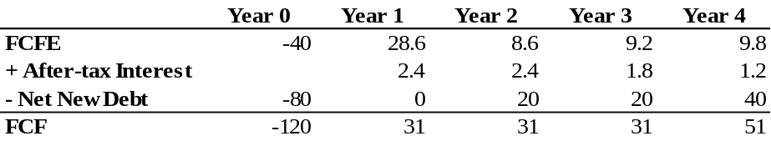
c. With predetermined debt levels, the APV method is easiest.
Step 1: Determine r_{U}. Assuming the company has maintained a historical D/E ratio of 0.20, we can approximate its unlevered cost of capital using Eq. 18.6:
r_{U} = (1 / 1.2) 11% + (0.2 / 1.2) 5% = 10%
Step 2: Compute NPV of FCF without leverage
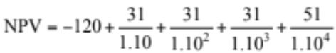= –8.1
Step 3: Compute APV
APV = NPV + PV(ITS) = −8.1 + 4.7 = −3.4
So the project actually has negative value.
18-18. Your firm is considering building a $600 million plant to manufacture HDTV circuitry. You expect operating profits (EBITDA) of $145 million per year for the next 10 years. The plant will be depreciated on a straight-line basis over 10 years (assuming no salvage value for tax purposes). After 10 years, the plant will have a salvage value of $300 million (which, since it will be fully depreciated, is then taxable). The project requires $50 million in working capital at the start, which will be recovered in year 10 when the project shuts down. The corporate tax rate is 35%. All cash flows occur at the end of the year.
a. If the risk-free rate is 5%, the expected return of the market is 11%, and the asset beta for the consumer electronics industry is 1.67, what is the NPV of the project?
b. Suppose that you can finance $400 million of the cost of the plant using 10-year, 9% coupon bonds sold at par. This amount is incremental new debt associated specifically with this project and will not alter other aspects of the firm’s capital structure. What is the value of the project, including the tax shield of the debt?
a. First we compute the FCF:
FCF₀ = –600 (Capex) – 50 (Inc in NWC) = –650
Using Eq. 7.6:
FCF_{1–9} = 145 × (1 – 0.35) + 0.35 × 60 = 115.25
After-tax Salvage Value = 300 × (1 – 0.35) = 195
FCF₁₀ = 145 × (1 – 0.35) + 0.35 × 60 + 50 (Inc in NWC) + 195 (salvage)
= 360.25
From the CAPM, r_{U} = 5% + 1.67(11% – 5%) = 15%
Therefore,
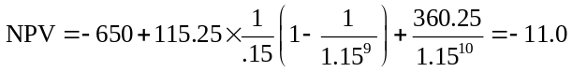
Without leverage, project NPV is –$11 million.
b. Because the debt level is predetermined, we can use the APV approach. Because the bonds initially trade at par, the interest payments are the 9% coupon payments of the bond. Assuming annual coupons:
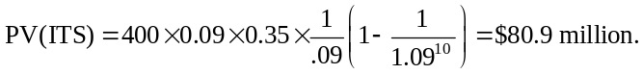
Therefore,
APV = NPV + PV(ITS) = –11 + 81 = $70 million.
Note that this project is only profitable as a result of the tax benefits of leverage.
18-19. DFS Corporation is currently an all-equity firm, with assets with a market value of $100 million and 4 million shares outstanding. DFS is considering a leveraged recapitalization to boost its share price. The firm plans to raise a fixed amount of permanent debt (i.e., the outstanding principal will remain constant) and use the proceeds to repurchase shares. DFS pays a 35% corporate tax rate, so one motivation for taking on the debt is to reduce the firm’s tax liability. However, the upfront investment banking fees associated with the recapitalization will be 5% of the amount of debt raised. Adding leverage will also create the possibility of future financial distress or agency costs; shown below are DFS’s estimates for different levels of debt:
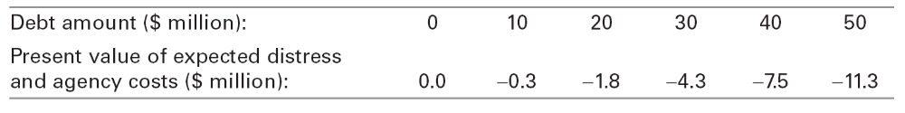
a. Based on this information, which level of debt is the best choice for DFS?
b. Estimate the stock price once this transaction is announced.
a. Because the debt is permanent, the value of the tax shield is 35% × D. From that we must deduct the 5% issuance cost, and the PV of distress and agency costs to determine the net benefit of leverage.

Debt Amount ($M): | 0 | 10 | 20 | 30 | 40 | 50
PV of Expected Distress and Agency Costs ($M): | 0.0 | –0.3 | –1.8 | –4.3 | –7.5 | –11.3
Tax Benefit less Issuance Cost (30%): | 0.0 | +3.0 | +6.0 | +9.0 | +12.0 | +15.0
Net Benefit: | 0.0 | +2.7 | +4.2 | +4.7 | +4.5 | +3.7

Based on this information, the greatest net benefit occurs for debt = $30 million.
b. Value of assets goes up from $100M to $104.7M. Thus, the share price should rise to $26.175.
18-20. Your firm is considering a $150 million investment to launch a new product line. The project is expected to generate a free cash flow of $20 million per year, and its unlevered cost of capital is 10%. To fund the investment, your firm will take on $100 million in permanent debt.
a. Suppose the marginal corporate tax rate is 35%. Ignoring issuance costs, what is the NPV of the investment?
b. Suppose your firm will pay a 2% underwriting fee when issuing the debt. It will raise the remaining $50 million by issuing equity. In addition to the 5% underwriting fee for the equity issue, you believe that your firm’s current share price of $40 is $5 per share less than its true value. What is the NPV of the investment including any tax benefits of leverage? (Assume all fees are on an after-tax basis.)
a. With permanent debt the APV method is simplest. NPV(unlevered) = –150 + 20 / 0.10 = $50 million. PV(ITS) = τ_{c} × D = 35% × 100 = $35 million. Thus, the NPV with leverage is APV = NPV + PV(ITS) = 50 + 35 = $85 million.
b. Financing costs = 2% × 100 + 5% × 50 = $4.5 million. (We assume these amounts are after tax.)
Underpricing cost = (5 / 40) × 50 = $6.25 million
APV = 85 – 4.5 – 6.25 = 74.25 million
18-21. Consider Avco’s RFX project from Section 18.3. Suppose that Avco is receiving government loan guarantees that allow it to borrow at the 6% rate. Without these guarantees, Avco would pay 6.5% on its debt.
a. What is Avco’s unlevered cost of capital given its true debt cost of capital of 6.5%?
b. What is the unlevered value of the RFX project in this case? What is the present value of the interest tax shield?
c. What is the NPV of the loan guarantees? (Hint: Because the actual loan amounts will fluctuate with the value of the project, discount the expected interest savings at the unlevered cost of capital.)
d. What is the levered value of the RFX project, including the interest tax shield and the NPV of the loan guarantees?
a. We use Eq. 18.6 with the true debt cost:
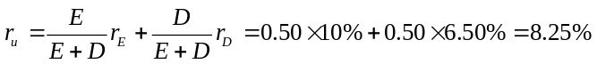
b. The unlevered value is the PV of the FCF discounted at r_{U}:
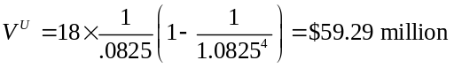
The amount of the interest tax shield each period is that same as computed in Table 18.5 in the text, but now we discount at r_{u} = 8.25%:
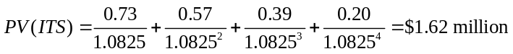
c. The loan guarantee reduces the interest paid from 6.5% to 6% each year. Thus, the savings in year t is 0.5% × D_{t–1}. The value of the loan guarantee is the present value of this savings. Because the debt amount D will vary with the value of the project over time, we discount the savings at rate r_{U}.
d. APV = V^{U} + PV(ITS) + NPV(Loan) = 59.29 + 1.62 + 0.34 = $61.25 million
Note that this is the same value we originally computed using the WACC method, where we used the firm’s actual borrowing cost rather than the true rate it would have received.
18-22. Arden Corporation is considering an investment in a new project with an unlevered cost of capital of 9%. Arden’s marginal corporate tax rate is 40%, and its debt cost of capital is 5%.
a. Suppose Arden adjusts its debt continuously to maintain a constant debt-equity ratio of 50%. What is the appropriate WACC for the new project?
b. Suppose Arden adjusts its debt once per year to maintain a constant debt-equity ratio of 50%. What is the appropriate WACC for the new project now?
c. Suppose the project has free cash flows of $10 million per year, which are expected to decline by 2% per year. What is the value of the project in parts (a) and (b) now?
a.
b. 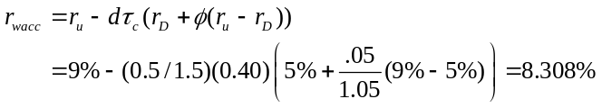
Alternatively, from Eq. 18.17:
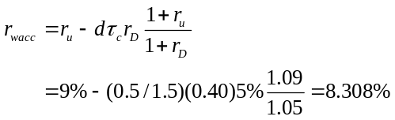
c. In case (a),
In case (b),
Note the minor difference in the two cases. Case (b) is higher because the tax shields are less risky when debt is fixed over the year.
18-23. XL Sports is expected to generate free cash flows of $10.9 million per year. XL has permanent debt of $40 million, a tax rate of 40%, and an unlevered cost of capital of 10%.
a. What is the value of XL’s equity using the APV method?
b. What is XL’s WACC? What is XL’s equity value using the WACC method?
c. If XL’s debt cost of capital is 5%, what is XL’s equity cost of capital?
d. What is XL’s equity value using the FTE method?
a. V^{U} = 10.9 / 10% = $109 million. PV(ITS) = 0.40 × $40 million = $16 million.
V^{L} = APV = 109 + 16 = $125 million, so E = 125 – 40 = $85 million.
b. 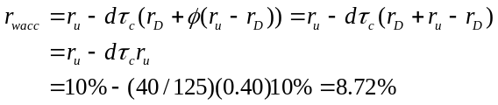
Using the WACC method, V^{L} = 10.9 / 8.72% = $125 million, so E = 125 – 40 = $85 million.
c. If XL’s debt cost of capital is 5%, what is XL’s equity cost of capital?
From Eq. 18.20:
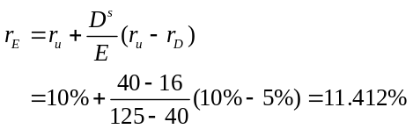
d. FCFE = FCF – After-tax Interest + Net new debt = 10.9 – 5%(1 – 0.40)40 = 9.7
E = 9.7 / 0.11412 = $85 million.
18-24. Propel Corporation plans to make a $50 million investment, initially funded completely with debt. The free cash flows of the investment and Propel’s incremental debt from the project follow:
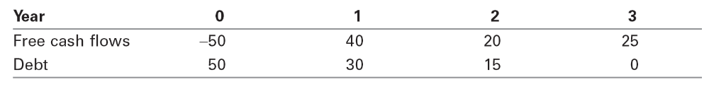
Propel’s incremental debt for the project will be paid off according to the predetermined schedule shown. Propel’s debt cost of capital is 8%, and its tax rate is 40%. Propel also estimates an unlevered cost of capital for the project of 12%.
a. Use the APV method to determine the levered value of the project at each date and its initial NPV.
b. Calculate the WACC for this project at each date. How does the WACC change over time? Why?
c. Compute the project’s NPV using the WACC method.
d. Compute the equity cost of capital for this project at each date. How does the equity cost of capital change over time? Why?
e. Compute the project’s equity value using the FTE method. How does the initial equity value compare with the NPV calculated in parts (a) and (c)?
a. Note that this answer actually uses the APV method instead of the WACC method.
We compute V^{U} at each date by discounting the project’s future FCF at rate r_{U} = 12%.
(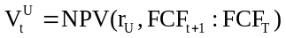):
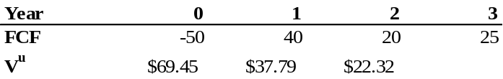
Then we compute the value of the future interest tax shields at each date by discounting at rate
r_{D} = 8%:
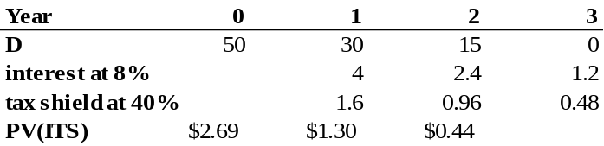
Finally, we compute V^{L} = APV = V^{U} + PV(ITS):
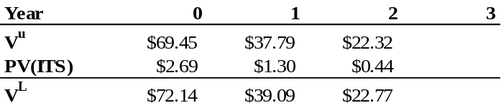
Given the initial investment of $50, the project’s NPV is 72.14 – 50 = $22.14.
b. We can compute the WACC at each date using Eq. 18.21. The debt-to-value ratio, d, is given by
D/V^{L}. The debt persistence φ is given by T^{s}/(τ_{c} D), where T^{s} =PV(ITS) (since all tax shields are predetermined):
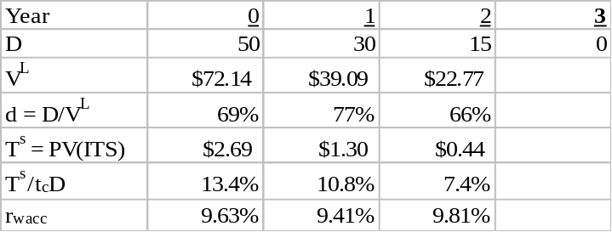
Note that the WACC changes over time, decreasing from date 0 to 1, and increasing from date 1 to 2. The WACC fluctuates because the leverage ratio of the project changes over time (as does the persistence of the debt).
c. We can compute the levered value of the project by discounting the FCF using the WACC at each date:
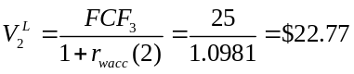
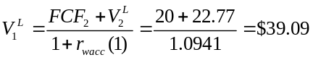
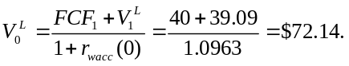
Note that these results coincide with part (a).
d. We can compute the project’s equity cost of capital using Eq. 18.20. Note that D^{s} = D − T^{s} = D − PV(ITS):
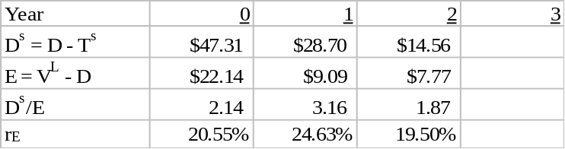
Note the equity cost of capital rises and then falls with the project’s effective debt-equity ratio, D^{s}/E.
e. We first compute FCFE at each date by deducting the after-tax interest expenses (equivalently, deducting interest and adding back the tax shield) and adding net increases in debt:
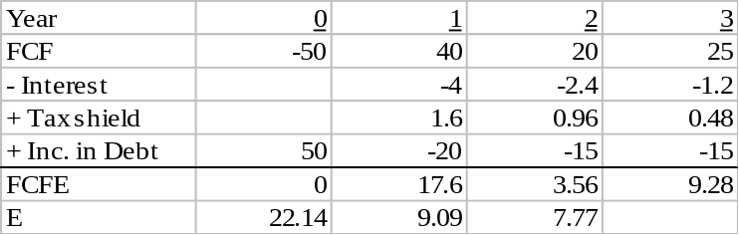
Then, we compute the equity value of the project by discounting FCFE using r_{E} at each date:
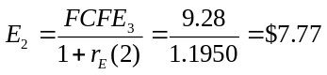
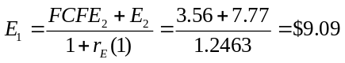
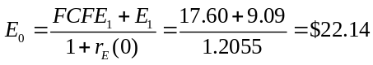
These values for equity match those computed earlier, and match the project’s initial NPV.
Note that to use the WACC or FTE methods here, we relied on V^{L} computed in the APV method. We could also solve for the value using the WACC or FTE methods directly using the techniques in appendix 18A.3.
18-25. Gartner Systems has no debt and an equity cost of capital of 10%. Gartner’s current market capitalization is $100 million, and its free cash flows are expected to grow at 3% per year. Gartner’s corporate tax rate is 35%. Investors pay tax rates of 40% on interest income and 20% on equity income.
a. Suppose Gartner adds $50 million in permanent debt and uses the proceeds to repurchase shares. What will Gartner’s levered value be in this case?
b. Suppose instead Gartner decides to maintain a 50% debt-to-value ratio going forward. If Gartner’s debt cost of capital is 6.67%, what will Gartner’s levered value be in this case?
a. From Eq. 18.25, τ∗ = 1 − (1 – 0.35)(1 – 0.20) / (1 – 0.40) = 13.333%.
Using the APV method, V^{L} = V^{U} + τ_{c} D = 100 + 0.1333× 50 = $106.67 million
b. With a constant debt-to-value ratio, the WACC approach is easiest. We need to determine Gartner’s WACC with this new leverage policy. To compute the WACC, we need to determine the new equity cost of capital using Eq. 18.24:
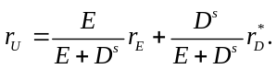
Because Gartner initially has no leverage, r_{U} = r_{E} = 10%. Next, r_{D}∗ = r_{D} (1 – τi)/(1 – τe) = 6.67%(1 – 0.40) / (1 – 0.20) = 5.00%. With a constant debt-to-value ratio, T^{s} = 0 and D^{s} / (E + D^{s}) = D /(E + D) = 50%. Thus,
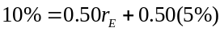
implying that r_{E} rises to 15%. Therefore, Gartner’s WACC is
We also need to estimate Gartner’s FCF. Based on its current market cap,
100 = FCF / (10% − 3%) implies FCF = $7 million.
Therefore, with the new leverage,
V^{L} = 7 / (9.67% – 3%) = $ 104.95 million.
18-26. Revtek, Inc., has an equity cost of capital of 12% and a debt cost of capital of 6%. Revtek maintains a constant debt-equity ratio of 0.5, and its tax rate is 35%.
a. What is Revtek’s WACC given its current debt-equity ratio?
b. Assuming no personal taxes, how will Revtek’s WACC change if it increases its debt-equity ratio to 2 and its debt cost of capital remains at 6%?
c. Now suppose investors pay tax rates of 40% on interest income and 15% on income from equity. How will Revtek’s WACC change if it increases its debt-equity ratio to 2 in this case?
d. Provide an intuitive explanation for the difference in your answers to parts (b) and (c).
a.
b. From Eq. 18.6:
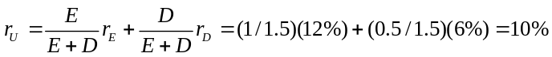
From Eq. 18.11:
c. Given their initial capital structure, we would estimate Revtek’s unlevered cost of capital as (using Eq. 18.24):
We can also use Eq. 18.24 to calculate r_{E} with higher leverage:
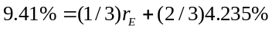 so that r_{E} = 19.76.
Then,
d. When investors pay higher taxes on interest income than equity income, the tax benefit of leverage is reduced. Thus, for the same increase in leverage, the decline in the WACC is smaller in the presence of investor taxes.

